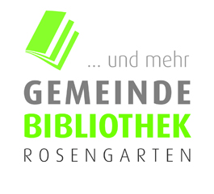

**Kulturmama’s   
English Storytime**

A free, fun-filled English story corner   
for your littlest literature lovers

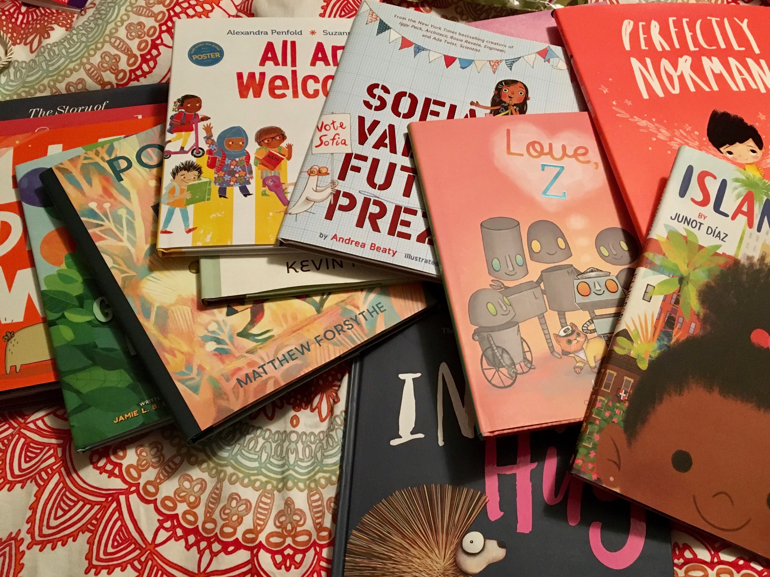

Intended for preschoolers (ages 3-5) and their caretakers, open to all

**Next Dates 2023:**  
January 16th, February 6th, March 13th,

April 3rd, May 15th, June 5th*

*Storytime Picnic in the library’s garden

at Gemeindebibliothek Rosengarten,

Freiestrasse 32 Thalwil

start @ 16:00h

free of charge



**Kulturmama’s   
English Storytime**

A free, fun-filled English story corner   
for your littlest literature lovers

Ein Bild, das Text enthält.

Intended for preschoolers (ages 3-5) and their caretakers, open to all

**Next Dates 2023:**  
January 16th, February 6th, March 13th,

April 3rd, May 15th, June 5th*

*Storytime Picnic in the library’s garden

at Gemeindebibliothek Rosengarten,

Freiestrasse 32 Thalwil

start @ 16:00h

free of charge